# User Manual

## Current Status

The current proto-type is able to generate VB.NET code for calling rules that have been added to an Excel sheet (see sections below for more info).

As this is still a proto-type under development, the VB.NET rules that will be called in the VB.NET code are currently empty.

When calling existing VB.NET example rules, the proto-type is able to generate compilable code.

## Data Flow

The diagram below summarizes the data flow. See section “Work Flow” for more detailed information about the different steps.

Generate

Generate and manually  
add rules

IHE-RO  
Original Documents  
.doc/.docx

Implementation  
Content Validation  
VB.NET

IOD Tables   
.csv (Excel)

Module Tables   
.csv (Excel)

Module Tables and Rules   
.csv (Excel)

Copy & paste

Copy & paste

Generate

## User Interface

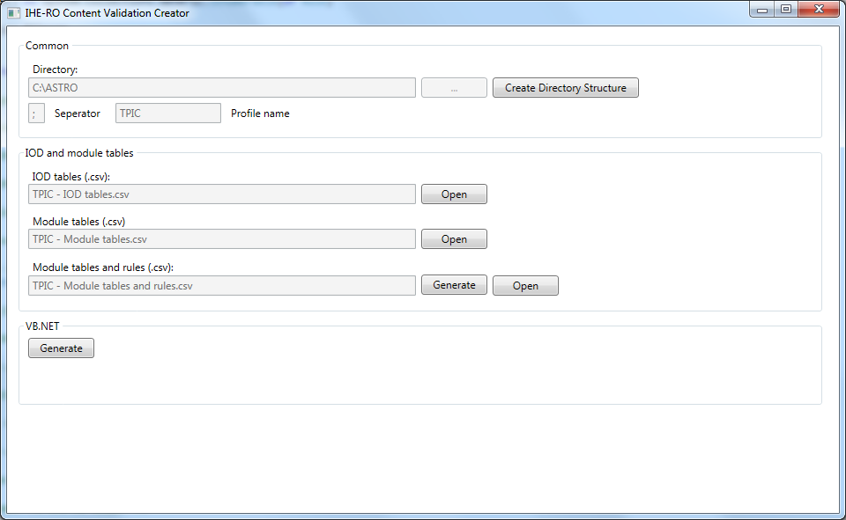

* “Create Directory Structure” button: create the directory structure under (the currently hardcoded) C:\ASTRO directory.
* “Open” button: opens the corresponding .csv file.
* “Module table and rules (.csv)” - “Generate” button: makes a copy of the “Module tables (.csv)” file, updates/adds some fields and writes it to the “Module table and rules (.csv)” file.
* “VB.NET” - “Generate” button: generates VB.NET code using the “Module table and rules (.csv)” file as source.

The “Module table and rules (.csv)” file is the file to manually add rules and conditions to. This file will be used as the source to generate VB.NET code with.

## Work Flow

The following steps need to be performed to be able to generate VB.NET code:

* Press the “Create Directory Structure” button.
* Open the “IOD tables (.csv)” file.
* Copy-and-paste (from the original IHE-RO document) the different IOD tables and IOD section headers. See “IHE-RO Content Validation Creator\Test data” for an example what parts to copy.
* Open the “Module table (.csv)” file. Select all fields and change the category from General to Text.
* Copy-and-paste (from the original IHE-RO document), using paste special/unicode text, the different module tables and module section headers. See “IHE-RO Content Validation Creator\Test data” for an example what parts to copy.
* Press the “Module table and rules (.csv)” - “Generate” button.
* Manually add rules and, if needed, conditions to the “Module table and rules (.csv)” file.
* Press the “VB.NET” - “Generate” button.

The Visual Studio Test project can be used to check that the generated Vb.NET code compiles correctly.

The “Test Data” directory already contains examples of the .csv files.

## Rules

Rules that may be used (using VB.NET syntax):

* **AttributeNotEmptyRule**  
  Attribute is present and contains one or more values
* **AttributePresentRule**  
  Attribute is present with or without values
* **AttributeNotPresentRule**  
  Attribute is not present

## Conditions

Conditions that may be used (using VB.NET syntax):

* **AttributeNotEmpty**  
   Attribute is present and contains one or more values
* **AttributePresent**  
  Attribute is present with or without values
* **AttributeNotPresent**  
  Attribute is not present
* **AttributeContainsValueAt (1-based index, list of values)**Attribute contains one of the supplied values at a specific index.  
    
  E.g. Condition for “Shall have a value if Value 3 of Image Type (0008,0008) is PORTAL or RADIOGRAPH.”   
  →   
  AttributeContainsValueAt(“0x0008 0008”, 3, “PORTAL”, “RADIOGRAPH”)